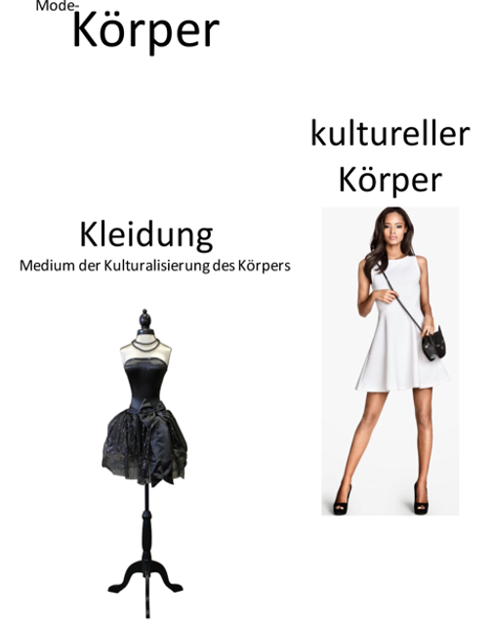

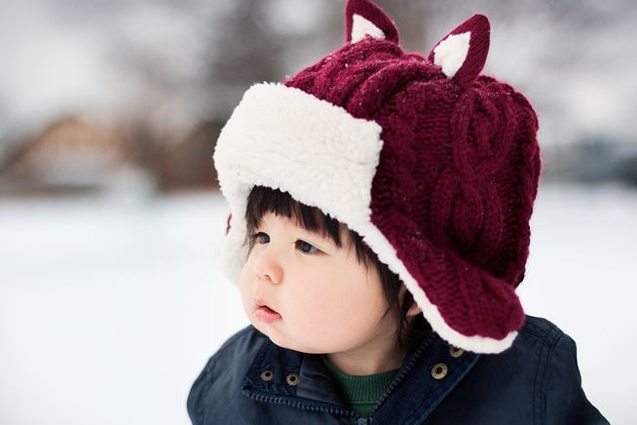 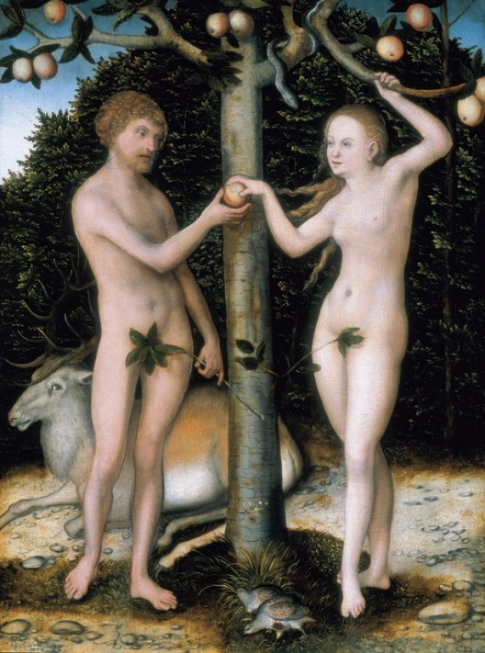

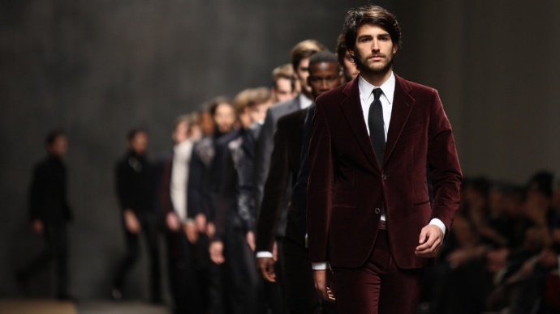 [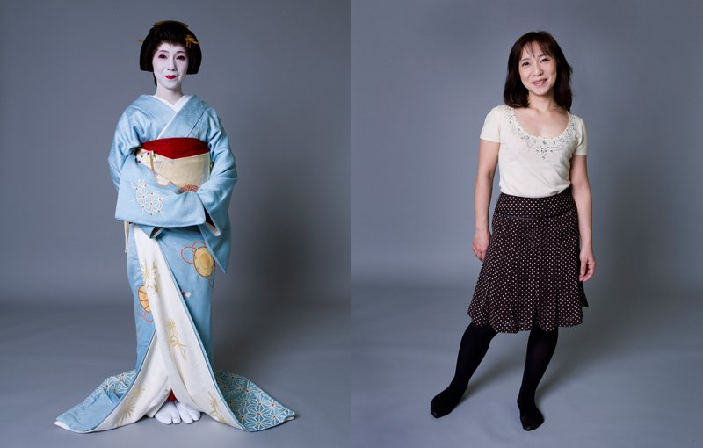](https://www.google.de/url?sa=i&rct=j&q=&esrc=s&source=images&cd=&cad=rja&uact=8&ved=2ahUKEwjj963e2p_gAhWKJ1AKHZp8AVcQjRx6BAgBEAU&url=https%3A%2F%2Fwww.evangelisch.de%2Fgalerien%2F1363%2F04-05-2012%2Fherlinde-koelbl-kleider-machen-leute&psig=AOvVaw1fSufAyoEEP5e2ej9Ipdp7&ust=1549288278574058)

